Temp. Sensor

A temperature sensor measures ambient temperatures of the world around it.  In this project, we will be displaying the temperature in the serial monitor of the Arduino IDE.

Hardware Required

* Arduino Uno
* USB A-to-B Cable
* Breadboard
* Temperature Sensor – LM35
* hook-up wires

Circuit

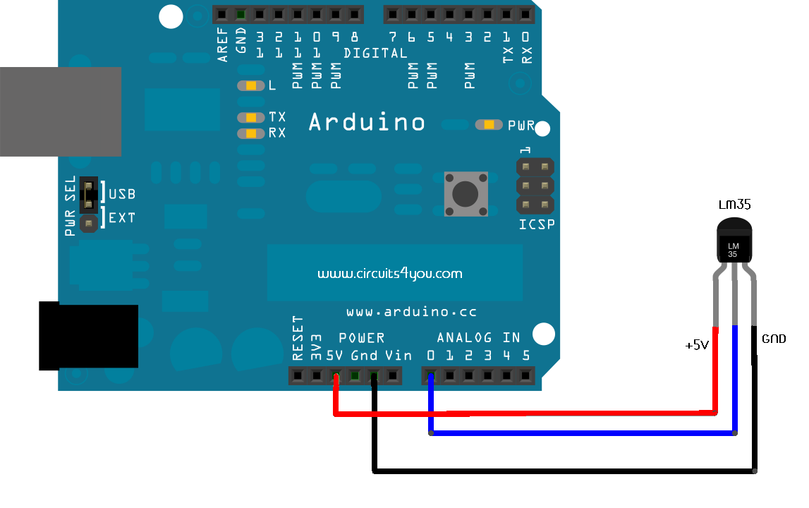

Code

int val;

int tempPin = 0;

void **setup**()

{

Serial.begin(9600);

}

void **loop**()

{

val = analogRead(tempPin);

float mv = ( val/1023.0)*5000;

float cel = mv/10;

float farh = (cel*9)/5 + 32;

Serial.print("TEMPRATURE = ");

Serial.print(cel);

Serial.print("*C");

Serial.println();

delay(1000);

/* uncomment this to get temperature in farenhite

Serial.print("TEMPRATURE = ");

Serial.print(farh);

Serial.print("*F");

Serial.println();

*/

}